Wellbeing Support

Responding to trauma

Gateshead Health NHS Foundation Trust

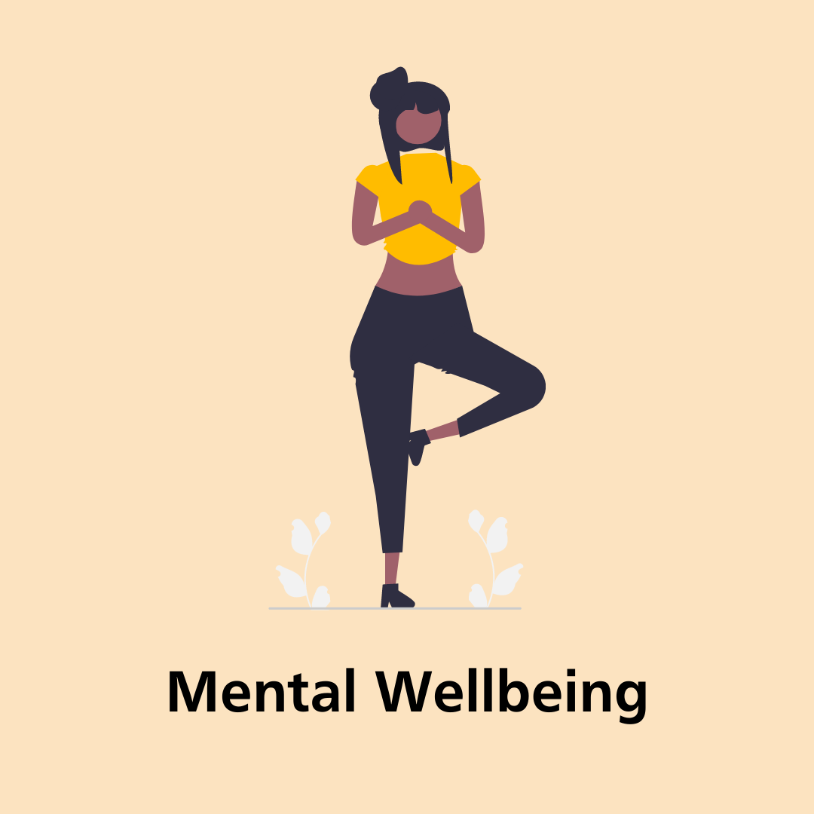
Looking after you following trauma:
In the aftermath of trauma, it is of vital importance that we find appropriate ways to support ourselves as we respond to feelings of unanticipated distress, stress, fright, grief and sadness.

The support that we need is unique to each of us, and can operate on a spectrum of one extreme to another. For some, space will be a necessity, for others the company of others will be a vital coping mechanism. Some may benefit from professional support, while some will find benefit in comforting others.

There is no one-size fits all solution to support and our support needs in response to trauma are varied. This document aims to outline the support available to all colleagues, in an attempt to ensure that we meet as many needs as is reasonably possible.

Further to the below document, a range of support is also available through balancegateshead.com, including more personal support options which cover underlying influences of mental wellbeing.

Those with suggested support additions to this document are asked to get in touch with the health and wellbeing team directly, who can arrange to update the document.

Get in touch on:
ghnt.hwb@nhs.net

Mental Health Diffusers:
A number of colleagues throughout the organisation have been trained as ‘diffusers’, there to provide immediate debrief to members of staff impacted by trauma or a traumatic incident.
The support offered by diffusers aims to ensure that colleagues feel support in the period immediately following an incident. Diffusers can help to identify further sources of support, and can signpost to further specialist support services where appropriate.
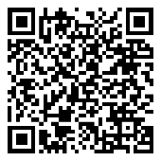
A number of our diffusers work nightshifts, and to this end the organisation aims to ensure that a diffuser is always available no matter the time that trauma occurs.
We advise you make contact with diffusers as soon as possible following an incident to provide immediate support. A full list of diffusers can be found via the QR code to the right or on balancegateshead.com.
Occupational Health:

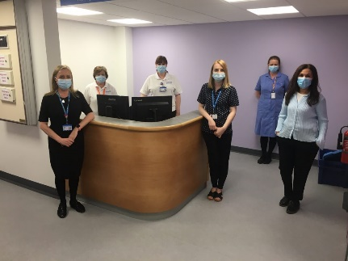
Where working hours allow, it is advised that you also immediately contact the Occupational Health team. The Occupational Health service is available between 08:30am – 5:00pm between Monday – Thursday, and 08:30am – 4:30pm on a Friday.

Contacting Occupational Health enables the team to prepare and provide direct support to those impacted by trauma. The team can work to identify and create a safe space for impacted colleagues, and will wherever possible also provide the emergency provision of listening support.

To make contact with Occupational Health on 0191 445 (5494).
Crisis support:

A number of organisations exist to support you in crisis following trauma. If you feel your life is at risk, please immediately call 999, visit A&E or contact your local crisis support team on 0800 652 2864. Those who need to a listening ear can also contact various 24/7 services, including:

- The Samaritans helpline on 116 123
- SHOUT’s conversation text service on 85258
- The National Suicide Prevention Service on 0800 689 5652

Counselling through Occupational Health:
All colleagues can refer themselves to our counselling service. Where preferred, colleagues can also ask their manager to make a referral on their behalf.
Talking therapies are for anyone who is going through a tough time or who has emotional problems that they need help with. Sessions provide you with the opportunity to talk about what is bothering you, look at your problems in a different way and an expert who will respect you.
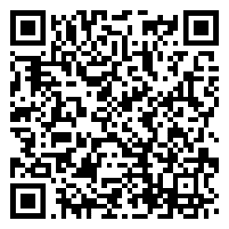
Counselling can be helpful in many scenarios, but particularly for those who experience depression, anxiety, eating disorders, phobias and addiction. These services may also be useful after traumatic events such as bereavement or personal issues.
To make a referral, please complete the referral form (also available through the QR code to the right) and send it to ghnt.occupational.health@nhs.net. In the case of referrals in direct response to traumatic/serious incidents, please indicate the referral is urgent and as a result of the incident in question.
NENC ICS Staff Wellbeing Hub – Counselling Support:
Colleagues who would prefer to access confidential support may wish to instead access the support offered by the North East and North Cumbria Integrated Care System’s (NENC ICS) Staff Wellbeing Hub.
As well as a confidential helpline, accessible on 0191 223 2030, colleagues can complete their dedicated online referral form to request support. This can also be accessed via the QR code to the right, below.
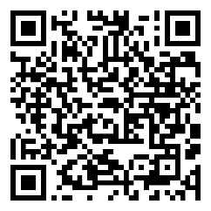
Referrals can also be made on behalf of a colleague where agreed. Please note that referrals to the NENC ICS Staff Wellbeing Hub are only picked up Monday to Friday (excluding any bank holidays), between 9:00am – 5:00pm. The Wellbeing Hub team can also be reached via Hubstheword@cntw.nhs.uk.

Mental Health First Aiders:
Gateshead Health is home to a dedicated team of trained mental health first aiders (MHFAs), there to support staff with their own mental health as well as the mental health of their colleagues.
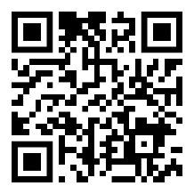
All MHFAs are trained and accredited by Mental Health First Aid England, and can help colleagues to recognise warning signs of mental ill health and access further support.
You can visit the Balance website for a full list of mental health first aiders at Gateshead, which can also be accessed through the QR code, right. Please feel free to contact someone who is close to your area or someone completely independent to your role/team.
Local Talking Therapies services:
Colleagues who are registered with a GP in the local area can also access NHS talking therapy services. Depending on the location of the GP you’re registered with, you can access and self-refer to:
- Gateshead Talking Therapies
  - Call 0191 283 2541
- Vita Health Group’s Newcastle Talking Therapies
- Sunderland IAPT
- South Tyneside Lifecycle Primary Care and Mental Health Service
- Talking Changes, for County Durham and Darlington
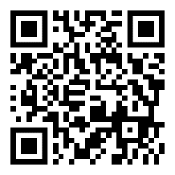
Practitioner Health:
NHS Practitioner Health is a mental health treatment service which offers targeted support for doctors and those who might otherwise not be able to access confidential care due to their role or team.
To register for this support, simply complete the dedicated registration form (accessible via the QR code to the right).
If you have any difficulties completing the form, please call 0300 0303 300 between Monday to Friday, 8:00am – 8:00pm or on Saturday between 8:00am – 2:00pm. Registrations are monitored between these same times. Please note Practitioner Health is closed on Bank Holidays.

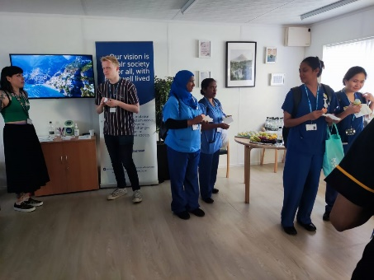
The Listening Space:
The Listening Space is a dedicated health and wellbeing facility on site at the QE Hospital, which is designed to provide colleagues with a space to reflect, decompress and access a listening ear. The room also hosts health and wellbeing-focused events, workshops and meetings, a schedule for which can be found on the health and wellbeing website.
The space is bookable for health and wellbeing purposes, and can be secured by emailing ghnt.hwb@nhs.net with your request.
You might use the space as a safe space for your team to benefit from a wellbeing-focused chat, or might use the space to book a chat with a mental health first aider.
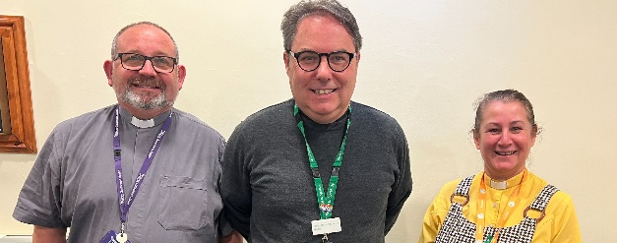
Chaplaincy:
Our Chaplaincy Centre is located opposite the entrance of The Hub at the QE Hospital. The chapel itself is open 24 hours per day, as is our multi-faith prayer room. All are welcome to use these facilities to find peace and quiet.
Our Chaplaincy Team are there to support all – including all staff, of any faith or none. Their work is to comfort you through times of difficulty and distress. The team are available 24 hours per day, and can be accessed by:
- Contacting switchboard to bleep the Duty Chaplain on call or the duty Roman Catholic Chaplain (please state clearly which is required)
- Calling 0191 445 (2072) and leaving a message. Please note that in emergency or urgent context, it is advised to use the switchboard.
Love and Loss Support Group:
The Love and Loss Support Group is a weekly dial-in session takes place every Tuesday between 7:30pm – 9:00pm and is facilitated by bereavement expert Piers Lance. Piers has over 35 years of experience in the area, and his sessions are designed to provide a safe space to explore your feelings and discuss any loss.
Discussing loss and hearing of the experiences and thoughts of others can be very helpful in better understanding and coming to terms with our feelings. All sessions are free-to-access, targeted to health and care colleagues from across Tyne & Wear, County Durham, Northumberland, Teesside and Cumbria, and are provided as part of the NENC ICS Staff Wellbeing Hub offer.
To access this support, please visit the Eventbrite booking page.

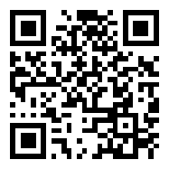
Cruse Bereavement:
Cruse offers specialist and personalised bereavement support to help you through the emotional pain of loss. Targeted support can be provided through the completion of a questionnaire which aims to provide you with the most relevant support.
Those looking to access Cruse immediately can also access direct support through their helpline on 0808 808 1677 (opening hours apply) or online CruseChat service.
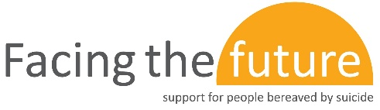
Facing the Future:
Another offer promoted by Cruse Bereavement Support in association with Samaritans, Facing the Future aims to provide support for those bereaved by suicide specifically.
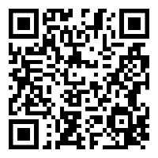
Group sessions are currently held by Zoom, last 90 minutes per session and are designed to be consumed as part of a six-week programme. Participants must attend at least five of six sessions, and must attend the first session.
To register for the sessions, visit the Face the Future registration page, also accessible via the QR code to the right.
If U Care Share – Support After Suicide:
If u care share’s Support After Suicide service is available to those who from Gateshead, Newcastle, Durham, North Tyneside, South Tyneside and Northumberland. The service aims to provide emotional support to those impacted by suspected suicide.
If you have lost someone to suicide, you are not alone. This services provides listening and support, and is available Monday to Friday between 09:00am – 5:00pm on 0191 387 5661.
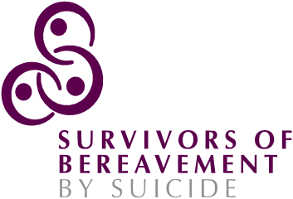
Survivors of Bereavement by Suicide (SOBS):
SOBS offers targeted support to those who have been bereaved or affected by suicide through a helpline of trained volunteers who have been in the same position.
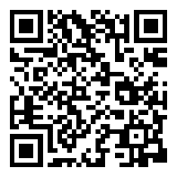
The SOBS national support line can be accessed on Mondays and Tuesdays between 09:00am – 5:00pm on 0300 111 5065. A network of local support groups is also available. You can find your local group through their finder tool via the QR code on the right.
Mind’s Bereavement Support:
Mind is home to a range of support, information, suggestions and advice to those who have experienced bereavement. Amongst the resources promoted by Mind include:
- Support on self-care for grief after bereavement
- Support around bereavement by suicide
- Supporting those who’ve experienced bereavement
Campaign Against Living Miserably (CALM):
CALM’s fantastic service directory provides signposting to support services and organisations across a number of specific issues.
Included amongst their promotion for bereavement support includes signposting to services who can assist more individual cases such as those facing child bereavement, those left behind by suicide and more.
You can visit the full directory, which also includes a range of signposting for other topics including mental health, depression and much more here.
WAY – Widowed and Young:
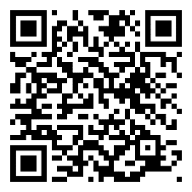
WAY is a membership organisation that looks to support anyone who has lost a partner and who is under the age of 50 years old.
Joining WAY costs £25 per year and grants you access to a wide range of peer-to-peer support groups, a community of people in similar situations, events held across the UK, a 24/7 confidential helpline and more. To join, visit their membership page via the QR code to the right.
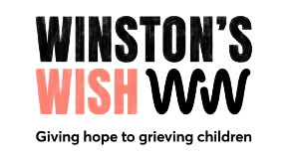
Winston’s Wish:
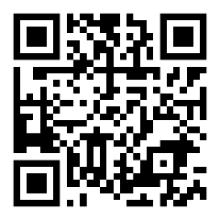
Winston’s Wish offers support and guidance to bereaved children and families. They can help with finding the words to explain death and suicide to children, can discuss funerals, responses and reactions and suggest ways or resources to support grieving children.
To access support through Winston’s Wish visit winstonswish.org via the QR code to the right, call 0808 8020 021 between Monday to Friday 09:00am – 5:00pm or e-mail ask@winstonswish.org.

balancegateshead.com:
Our dedicated health and wellbeing website is designed to provide you with an awareness of and access to our health and wellbeing offer, including signposting to and information about our partners.
Via the website, you can find further support, resources and information around self-care as well as mental, physical, financial, social and environmental wellbeing.
To access the website, visit balancegateshead.com. To access the most relevant support quickly, we advise you use the search button in the top right corner of the website.
Occupational Health and Wellbeing:
In addition to the resources held via our website, we also have a dedicated occupational health and wellbeing team who have a great awareness of both our own overarching occupational health and wellbeing offer as well as the wider environment.
The team are happy to try help wherever possible and can be reached via ghnt.hwb@nhs.net.
NENC ICS Staff Wellbeing Hub:
In addition to the counselling provision offered by the NENC ICS Staff Wellbeing Hub, the team also provides all Gateshead colleagues with access to a diverse range of health and wellbeing support resources and offers, accessible through their wellbeing hub website.
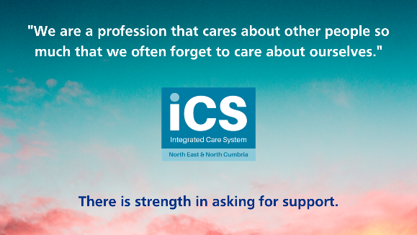
Amongst the resources promoted by the wellbeing hub includes:
- Wellbeing offers which include self-compassion courses, CBT programmes, support groups, physical activity events, mindfulness activities and more.
- Their wellbeing diary, a self-help tool which helps you to monitor your wellbeing and identify trigger points, coping mechanisms and drivers of good wellbeing.
- A wellbeing toolkit, which aims to help you build the coping mechanisms needed to manage your wellbeing.
Tyneside Mind:
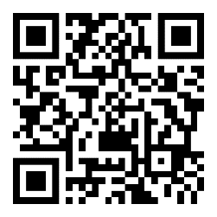
Providing mental health support for all, Tyneside Mind offers a range of services to support people and families throughout Tyneside and Northumberland. Included amongst these services can include counselling and therapy, wellbeing and resilience offers, signposting for urgent help needs and what to do if you’re worried about someone else.
To get in touch with Tyneside Mind, call 0191 477 4545 or 0330 174 3174 between 08:00am – 10:00pm on any day of the week.
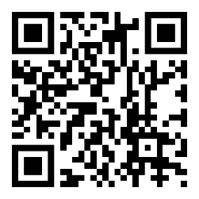
If U Care Share - crisis text support:
A crisis text support service is available through If U Care Share, and is staffed by trained volunteers who can be on hand to support you with a range of common issues including abuse, anxiety, bullying, depression, loneliness, self-harm and suicide.
To lean on this support service, text IUCS to 85258.
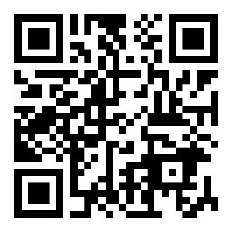
PAPYRUS Prevention of Young Suicide:
PAPYRUS is a UK charity dedicated to the prevention of suicide and the promotion of positive mental health and emotional wellbeing amongst young people. The service is there for those aged between 18 – 25.
To access this support, call 0800 068 4141 or visit papyrus-uk.org.
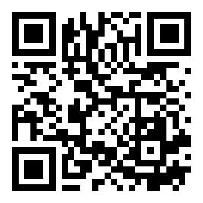
Muslim Community Helpline:
Providing confidential support for any members of the Muslim community, this helpline provides a free and non-judgmental listening and emotional support service.
The helpline can be contacted via 0208 908 6715 or 0208 904 9183. For information on opening hours, visit muslimcommunityhelpline.co.uk. The helpline can also be contacted via email on ess4m@btinternet.com.

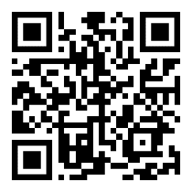
Charlie Waller:
Charlie Waller provides mental health training as well as free guides and workbooks professionals, parents, young people and anyone else interested in mental wellbeing.
To access their guidance, visit charliewaller.org or scan the QR code to the right.
StayAlive:
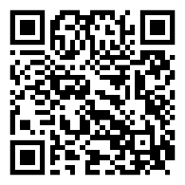
The StayAlive app was developed by Grassroots Suicide Prevention and is a suicide prevention resource packed full of useful information, resources and tools to help keep you safe in a crisis.
StayAlive can be used when experiencing intrusive thoughts or suicidal feelings, or if you are concerned about someone else you think may be considering suicide. The app is available free on iOS and Android devices and tinyurl.com/stayalive-gh.

