|  |  |  |  |  |  |  |  |  |
| --- | --- | --- | --- | --- | --- | --- | --- | --- |
|  | QE Health and Wellbeing Newsletter | | | | |  | | |
|  | C:\Users\fior.sayer\Pictures\logo.pngISSUE NO 1 | August - 2022 | VOLUME | | | | |  | | |
|  |  | | | | | Topic 01  Our Services | | |
|  |  |  |  |
|  | Topic 02  Objectives and Alexander Adventures | | |
|  |  | | | | |
|  |  |  |  |  |  |  |  |  |
|  | The QE has supported development of this independent Health and Wellbeing initiative.  The aim is to improve nursing and medical staff wellbeing.  This is a priority and part of the Trust’s Covid recovery initiative to rebuild staff strength and wellbeing the trust acknowledges that teams need to be both physically and | | | mentally well to look after their patient’s.  The group aims to provide nursing and medical staff a time away from the workplace to enjoy the outdoors and take part in full inclusive sessions. | Topic 03  Click the link to see our story in the local newspaper. See our up and coming activities | | |

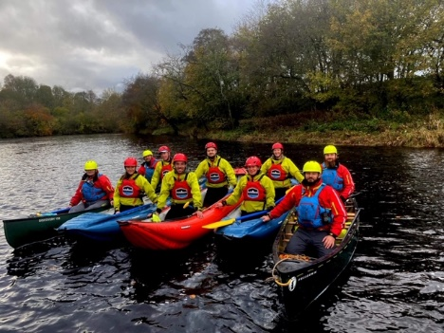

We’re proud to work and lucky to work with Alexander Adventure to provide enjoyable, relaxing and mental health boosting adventure days for our healthcare workers. 

FIND MORE ABOUT OUR TAILORED NHS DAYS HERE: <HTTPS://ALEXANDERADVENTURES.CO.UK/ACTIVITIES/NHS-EVENTS/>

Alexander Adventures

To book your spot on an upcoming activity follow the link above and /or just join the Activity Group's Facebook page and register your interest.

Its main objectives are to provide a diverse range of outdoor activities for nursing and medical staff. These days already do and will continue to provide time away from work and the intensity and pressure that comes with it. These sessions will provide NHS staff with a much-needed opportunity to reflect, relax, increase personal and staff esteem and wellbeing.

|  |  |  |  |  |  |  |  |
| --- | --- | --- | --- | --- | --- | --- | --- |
| ISSUE NO 1 | August - 2022 | VOLUME 1 | | | | | | |  |
| Click the link below to read our recent article in the local newspaper  <https://www.chroniclelive.co.uk/news/north-east-news/fior-sayer-gateshead-queen-elizabeth-24597467> | | | | Fior Sayer, 40 works at the Queen Elizabeth Hospital in Gateshead and is aiming to improve the health and wellbeing of the staff | | | |
| “She recognised I was struggling in 2021 and was there for me and got me out the house for walks, beach days, etc. What started as sharing her love of the outdoors, she has now become the QE well-being team member and works with Alexander Adventures to raise money for QE trust staff to book onto events."  - Henriette Andersen | | | | | |  | |
|  | | | | |  | | |
|  | | | | |  | | |
|  |  |  |  | |
|  | |  |  | |
|  | |  |  | |

**Here is a list of the activities that are coming ;**

**12/8/22** Scafell Mountain day

**22/8/22** NHS team day Introduction to sea kayaking

**7/9/22** 2 day NHS Lakes Adventure including walk, paddle boarding and swimming. Camping over night.

**12/9/22** NHS Coastal Walk and BBQ

**16/9/22** Introduction to Mixed Water Sports at Chester le Street

**3/10/22** St Abbs Multi Activity Adventure with glamping overnight stay

**10/10/22** Introduction to Mixed Water Sports at Chester le Street.

**28/11/22** White Water Canoeing day Trip along the Tyne